|  |
| --- |
| Microsoft Corporation |
| TSL Power Tools |
| Routines for web and load testing with Visual Studio 2010 |

|  |
| --- |
| Microsoft Testing Services  12/27/2011 |

# Custom Counter Sets

The following custom counter sets are included with the tools. To use them, copy them to C:\Program Files (x86)\Microsoft Visual Studio 10.0\Common7\IDE\Templates\LoadTest\CounterSets and then restart Visual Studio.

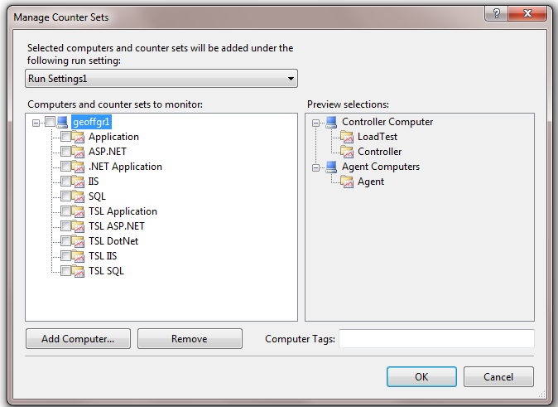

The following outlines the counter CATEGORIES contained in each set. Mix and match them as you need:

<CounterSet Name="**TSL ASP.NET**"

<CounterCategory Name="ASP.NET">

<CounterCategory Name="ASP.NET Applications">

<CounterCategory Name="Web Service">

<CounterSet Name="**TSL Application**"

<CounterCategory Name="Memory">

<CounterCategory Name="Network Interface">

<CounterCategory Name="PhysicalDisk">

<CounterCategory Name="Processor">

<CounterCategory Name="System">

<CounterCategory Name="Process">

<CounterSet Name="**TSL DotNet**"

<CounterCategory Name=".NET CLR Exceptions">

<CounterCategory Name=".NET CLR Interop">

<CounterCategory Name=".NET CLR LocksAndThreads">

<CounterCategory Name=".NET CLR Memory">

<CounterSet Name="**TSL IIS**"

<CounterCategory Name="Active Server Pages">

<CounterCategory Name="Web Service">

<CounterSet Name="**TSL SQL**"

<CounterCategory Name="Memory">

<CounterCategory Name="Network Interface">

<CounterCategory Name="PhysicalDisk">

<CounterCategory Name="Processor">

<CounterCategory Name="System">

<CounterCategory Name="Process">

<CounterCategory Name="SQLServer:Access Methods">

<CounterCategory Name="SQLServer:Databases">

<CounterCategory Name="SQLServer:General Statistics">

<CounterCategory Name="SQLServer:Latches">

<CounterCategory Name="SQLServer:Locks">

<CounterCategory Name="SQLServer:SQL Statistics">